Exercises: Keyframe Interpolation

Exploring the Graph Editor
Theory Through Practice tasks for the “Keyframe Interpolation. Exploring the Graph Editor” lesson.

Animate movement across path
Animate the movement of a ball from point A to point B on a straight path

Examples


Hints
- Set a start and end keyframes for Position
- Set mid point keyframes for Scale and Opacity

Apply smooth momentum the movement of the ball across a path

Continuing with the previous composition, apply easing presets

Examples


Hints
  - Apply Easy Ease, Ease In, Ease Out
  - Separate motion in three different compositions

Customize the smoothness in the movement of the ball across a path
Continuing with the compositions in the previous task, change the smootness of the motion to your liking

Examples


Hints
  - Start from Easy Ease, Ease In, Ease Out
  - Apply changes to the animation curves in Graph Editor
  - Separate Dimensions
  - Separate motion in three different compositions


Animating a yo-yo
Create an animation of the movement of the Sun

Examples

Hints
- Animate the change of Position
- Apply Easing and Motion Blur
- Parent rope layer to yoyo
* Bonus: Apply Rotation. Animate stretching of the rope

Create animation of a monster teleporting from point A to point B

Examples
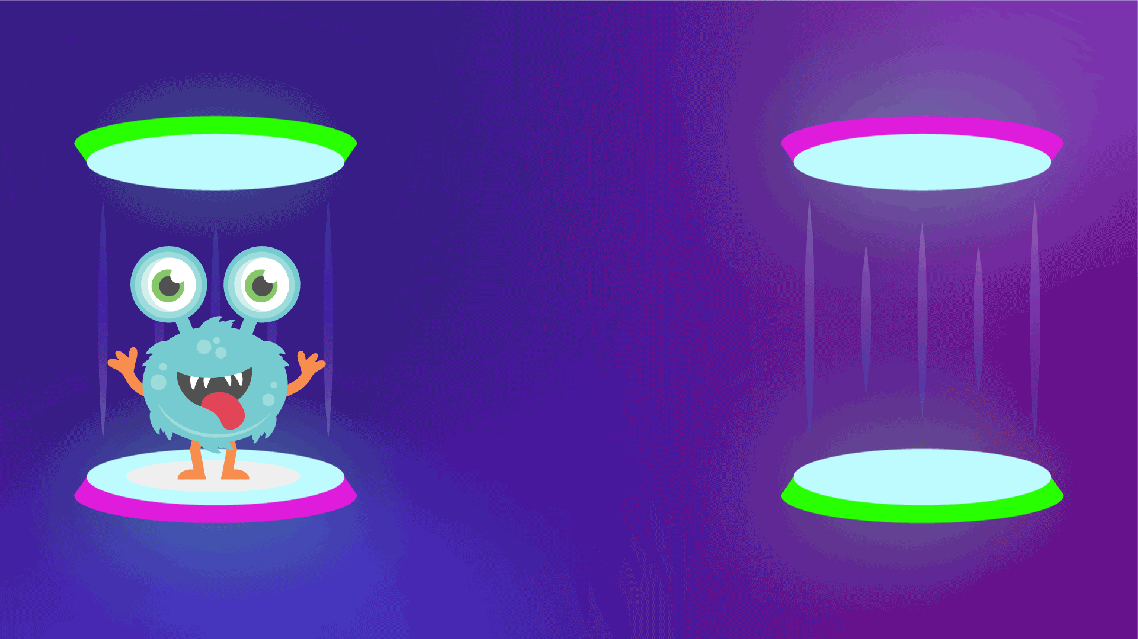

Hints
- Find/create an illustration of a monster with transparent background
- Use Toggle Hold Interpolation

Bouncing ball *
Using your knowledge in keyframe interpolation and curves, create an animation of a bouncing ball

Examples


Hints
- Create using shape layer
- Customize the animation curves in Graph Editor
- Apply “Squash and stretch principle” of animation
- Research online to complete this exercise

**Bonus: Add texture. Apply rotation to the texture

Tiny wings game**
Using the assets provided, animate a bird sliding on hills

Examples
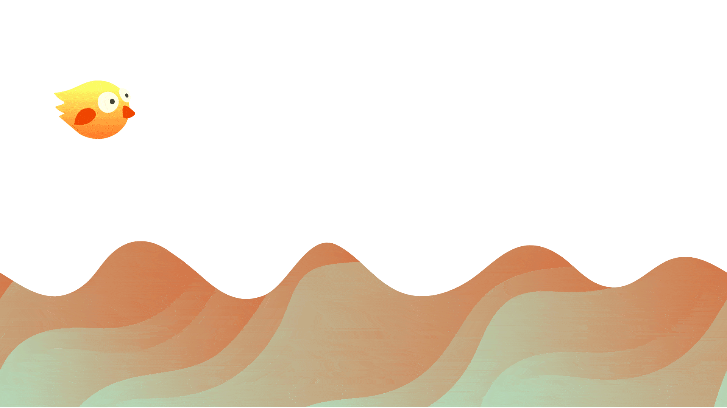

Hints
- Animate Y Position for parent object
- Move background
- Apply customized easing in Graph Editor
- Match Easing of object and background

Generating ideas***
Create an animation of a person generating ideas. Use the storyboard as a guide to create the sequences. 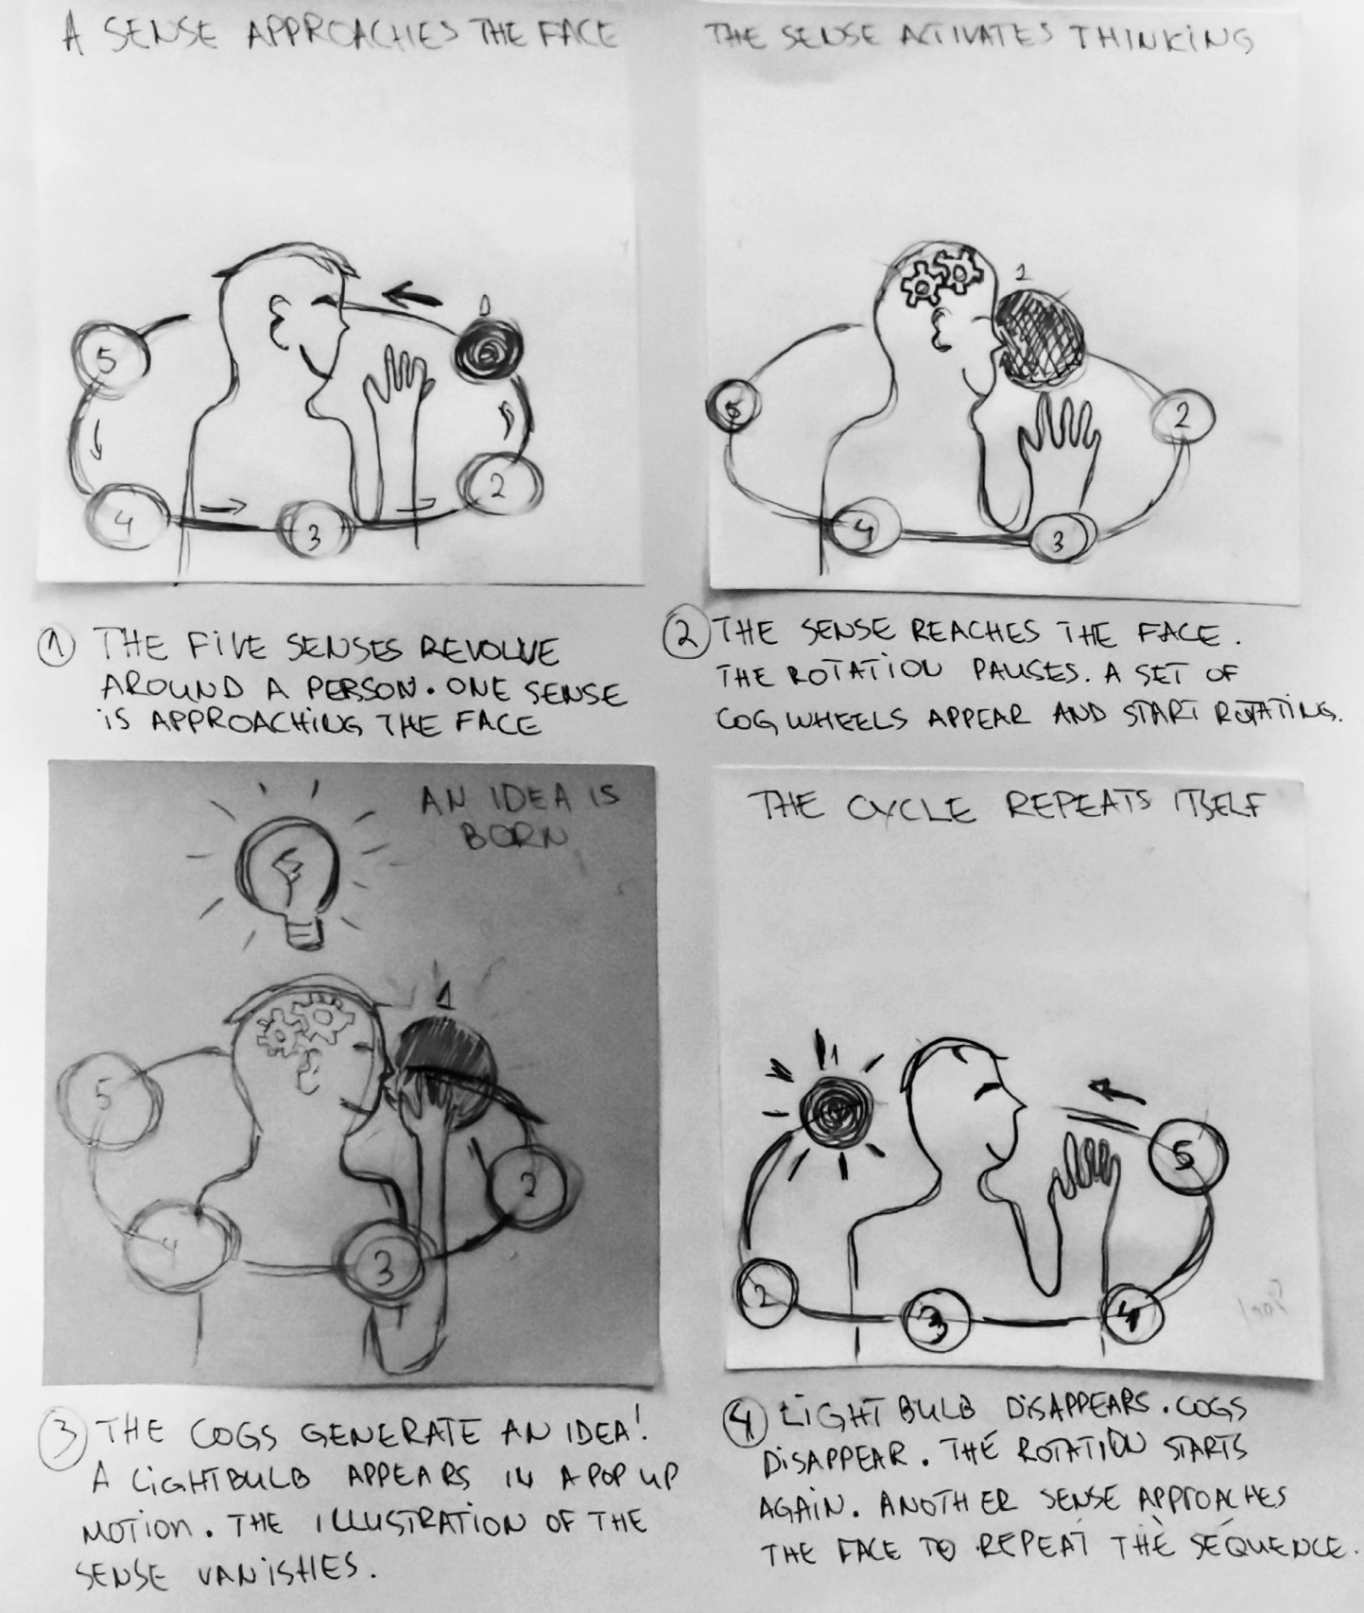

Hints
- Use assets provided, and find additional images online/create them yourself
- Use Opacity, Position, Rotation and Scale
- Use the overshoot expression
- Do not forget Motion Blur

